SIMULATION EXPERIMENT – 6
INDUSTRIAL HVAC CONTROL FIRMWARE: ADC TEMPERATURE ACQUISITION AND TIMER-INTERRUPT PWM FAN CONTROL
CO Mapping: CO2
Bloom's Level: K3 – Apply
WK Level: WK3 – Application of fundamental engineering and computing principles
➔ Objectives of this Experiment:
- To understand the operation of the Arduino UNO ADC for analog temperature acquisition.
- To interface an LM35 temperature sensor with the Arduino UNO.
- To acquire and convert the LM35 analog output into temperature values using Embedded C programming.
- To implement timer-interrupt-based software PWM for fan-speed control.
- To control an HVAC fan according to the measured temperature.
- To display the temperature and corresponding PWM duty cycle through the Proteus Virtual Terminal.
- To simulate and verify the HVAC control firmware using Proteus software.
➔ Expected Outcome from this Experiment:
Students shall be able to:
- Configure the Arduino UNO ADC for analog sensor acquisition.
- Interface an LM35 temperature sensor with an Arduino analog input.
- Convert ADC readings into temperature values.
- Implement temperature-based control logic using Embedded C.
- Configure Timer1 for interrupt-based PWM generation.
- Control a DC motor representing an HVAC fan using PWM.
- Verify different fan-speed conditions through Proteus simulation.
- Analyze the relationship between temperature, PWM duty cycle and fan operation.
➔ Software Required:
S. No. | Software | Purpose
1 | Proteus Design Suite 8 | Circuit design and simulation
2 | Arduino IDE | Embedded C program development and HEX generation
➔ Hardware Components Used in Simulation:
S. No. | Component | Quantity
1 | Arduino UNO | 1
2 | LM35 Temperature Sensor | 1
3 | DC Motor – MOTOR-DC | 1
4 | BC547 NPN Transistor | 1
5 | 1N4007 Diode | 1
6 | 1 kΩ Resistor | 1
7 | Virtual Terminal | 1
8 | +5V Power Terminal | As required
9 | GND Power Terminal | As required
➔ Objective Linkage:
The experiment enables students to:
- Develop an Embedded C program for Arduino UNO.
- Acquire analog temperature information using the built-in ADC.
- Interface the LM35 temperature sensor with analog input A0.
- Convert the ADC reading into temperature in degrees Celsius.
- Implement temperature-based fan-speed control.
- Configure Timer1 to generate periodic interrupts.
- Generate software PWM using the Timer1 interrupt.
- Control a DC motor representing an industrial HVAC fan.
- Display temperature and PWM information through the Virtual Terminal.
- Verify the complete HVAC control operation through Proteus simulation.
➔ Theory:
The Arduino UNO is based on the ATmega328P microcontroller and provides a built-in 10-bit Analog-to-Digital Converter (ADC). The ADC converts an analog input voltage into a digital value ranging from 0 to 1023.
In this experiment, an LM35 precision temperature sensor is used to acquire the temperature. The LM35 produces an analog voltage proportional to temperature, with an approximate sensitivity of:
10mV/ ºC
The LM35 output is connected to Arduino analog input A0.
The Arduino ADC converts the LM35 output voltage into a digital value. The temperature is calculated from the ADC reading using:
V_{ADC} = (ADC x 5.0) / 1023
Since the LM35 produces approximately 10 mV per degree Celsius:
Temperature = V_{ADC} x 100
The measured temperature is then used to determine the required fan speed.
A DC motor is used to represent the HVAC fan. The motor is controlled through a BC547 transistor driver. A 1N4007 diode is connected across the motor to provide protection against the voltage generated by the inductive motor load.
Instead of using the Arduino analogWrite() function, this experiment implements software PWM using a Timer1 interrupt. Timer1 is configured in CTC mode and periodically generates an interrupt. The interrupt service routine maintains a PWM counter and compares it with the selected duty cycle.
The temperature-dependent fan control used in this experiment is:
Temperature | PWM Duty Cycle | Fan Condition
< 25°C | 0% | OFF
25–29°C | 30% | LOW
30–34°C | 60% | MEDIUM
≥ 35°C | 90% | HIGH
Thus, the control sequence is:
Temperature
│
▼
LM35 Sensor
│
▼
Arduino ADC
│
▼
Temperature Calculation
│
▼
Temperature-Based PWM Selection
│
▼
Timer1 Interrupt
│
▼
Software PWM
│
▼
BC547 Driver
│
▼
HVAC Fan
The temperature and PWM duty cycle are transmitted through the Arduino serial interface and displayed using the Proteus Virtual Terminal.
➔ Experimental Procedure:
A. Proteus Circuit Development
- Open the Proteus Design Suite.
- Create a new schematic design.
- Select and place the Arduino UNO.
- Select and place the LM35 temperature sensor.
- Connect LM35 Pin 1 (VCC) to +5V.
- Connect LM35 Pin 2 (VOUT) to Arduino A0.
- Connect LM35 Pin 3 (GND) to GND.
- Select and place the MOTOR-DC component to represent the HVAC fan.
- Select and place the BC547 NPN transistor.
- Connect Arduino D8 to a 1 kΩ resistor.
- Connect the 1 kΩ resistor to the base of BC547.
- Connect the BC547 emitter to GND.
- Connect the BC547 collector to the negative terminal of the DC motor.
- Connect the positive terminal of the DC motor to +5V.
- Place the 1N4007 diode across the DC motor.
- Connect the cathode/striped end of the 1N4007 to the motor positive supply.
- Connect the anode/non-striped end to the motor and transistor collector junction.
- Select and place the Virtual Terminal.
- Connect Arduino D1/TX to the Virtual Terminal RXD.
- Leave Virtual Terminal TXD, RTS and CTS unconnected.
- Configure the Virtual Terminal for 9600 baud.
- Complete and verify all circuit connections.
- Develop the Arduino Embedded C program.
- Compile the program using the Arduino IDE.
- Generate the corresponding HEX file.
- Load the generated HEX file into the Arduino UNO component in Proteus.
B. Program Execution and Verification
- Start the Proteus simulation.
- Observe the temperature value displayed by the LM35.
- Verify that the Arduino acquires the LM35 output through analog input A0.
- Observe the temperature value displayed on the Virtual Terminal.
- Verify the corresponding PWM duty cycle.
- Observe the DC motor representing the HVAC fan.
- Change the LM35 temperature parameter in Proteus.
- Verify that the PWM duty cycle changes according to the temperature.
- Verify 0% PWM for temperatures below 25°C.
- Verify 30% PWM for temperatures between 25°C and below 30°C.
- Verify 60% PWM for temperatures between 30°C and below 35°C.
- Verify 90% PWM for temperatures of 35°C and above.
- Observe the corresponding change in fan operation.
- Verify the temperature and PWM information through the Virtual Terminal.
- Record the simulated observations.
➔ PROGRAM:
#define TEMP A0
#define FAN 8

volatile byte pwm = 0;
volatile byte count = 0;

ISR(TIMER1_COMPA_vect)
{
count++;

if (count >= 100)
count = 0;

digitalWrite(FAN, count < pwm);
}

void setup()
{
Serial.begin(9600);
pinMode(FAN, OUTPUT);

TCCR1A = 0;
TCCR1B = (1 << WGM12) | (1 << CS11);

OCR1A = 199;

TIMSK1 = (1 << OCIE1A);

sei();
}

void loop()
{
int adc = analogRead(TEMP);

float temp = adc * 500.0 / 1023.0;

if (temp < 25)
pwm = 0;
else if (temp < 30)
pwm = 30;
else if (temp < 35)
pwm = 60;
else
pwm = 90;

Serial.print("Temperature: ");
Serial.print(temp, 1);

Serial.print(" C PWM: ");
Serial.print(pwm);

Serial.println("%");

delay(1000);
}
➔ Program Explanation:
Instruction / Section | Function
#define TEMP A0 | Defines Arduino A0 as the LM35 analog input
#define FAN 8 | Defines Arduino D8 as the PWM fan-control output
volatile byte pwm | Stores the selected PWM duty cycle
volatile byte count | Stores the software PWM counter
ISR(TIMER1_COMPA_vect) | Defines the Timer1 compare-match interrupt service routine
count++ | Increments the PWM counter
count >= 100 | Resets the PWM counter after 100 steps
digitalWrite(FAN, count < pwm) | Generates the software PWM signal
Serial.begin(9600) | Initializes serial communication
pinMode(FAN, OUTPUT) | Configures D8 as an output
TCCR1A = 0 | Clears Timer1 control configuration
TCCR1B | Configures Timer1 in CTC mode with prescaler
OCR1A = 199 | Sets the Timer1 compare value
TIMSK1 | Enables Timer1 Compare A interrupt
sei() | Enables global interrupts
analogRead(TEMP) | Reads the LM35 analog signal
temp = adc * 500.0 / 1023.0 | Converts ADC reading into temperature
pwm = 0 | Turns the fan OFF below 25°C
pwm = 30 | Sets 30% PWM for 25–29°C
pwm = 60 | Sets 60% PWM for 30–34°C
pwm = 90 | Sets 90% PWM at 35°C and above
Serial.print() | Displays temperature and PWM information

➔ CIRCUIT DIAGRAM:
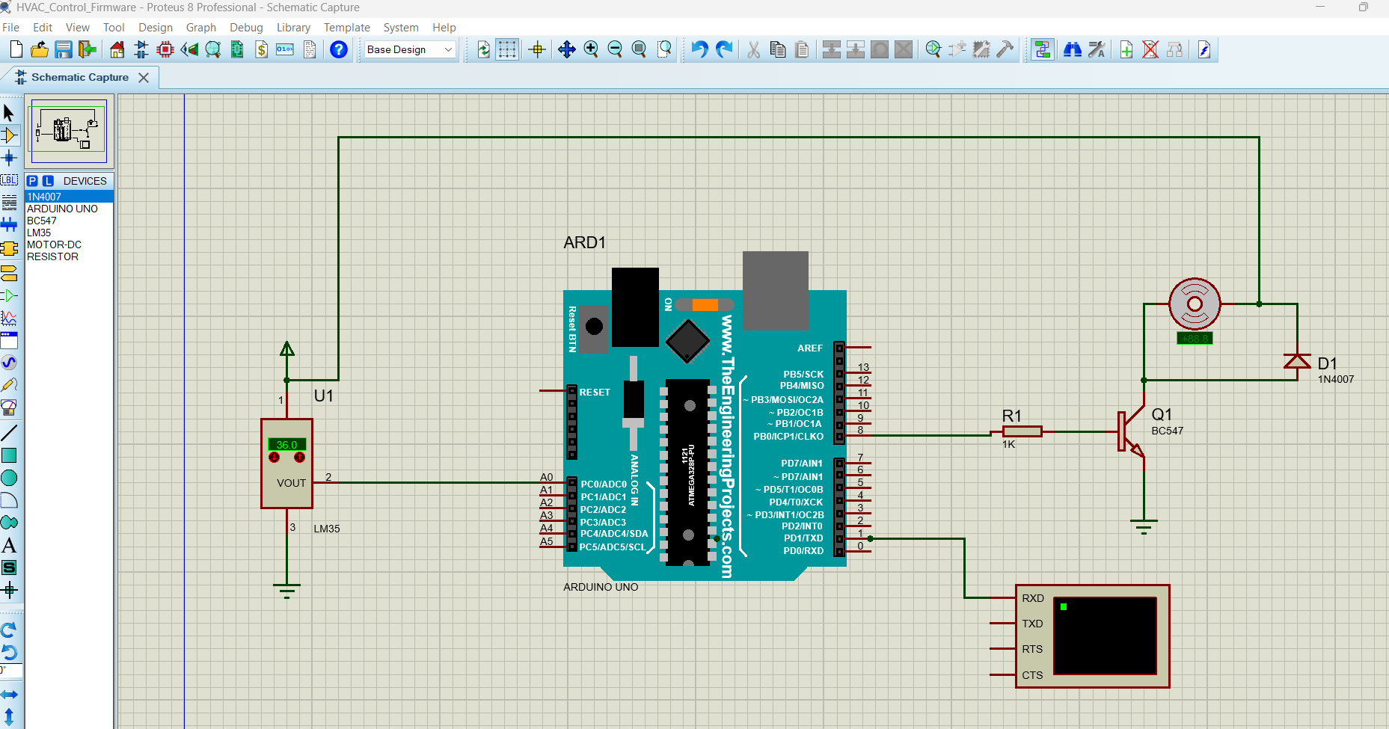
Arduino UNO – LM35 and HVAC Fan Interface
Connection:
Component | Connection
LM35 Pin 1 – VCC | +5V
LM35 Pin 2 – VOUT | Arduino A0
LM35 Pin 3 – GND | GND
Arduino D8 | 1 kΩ resistor
1 kΩ resistor | BC547 Base
BC547 Emitter | GND
BC547 Collector | Motor negative terminal
Motor positive terminal | +5V
1N4007 Cathode | Motor positive / +5V
1N4007 Anode | Motor negative / BC547 collector
Arduino D1/TX | Virtual Terminal RXD
Virtual Terminal TXD | NC
Virtual Terminal RTS | NC
Virtual Terminal CTS | NC
➔ INPUT PARAMETER TABLE – VALUES TO BE ENTERED
S. No. | Input Parameter | Symbol / Setting | Value to Enter | Unit
1 | Microcontroller | Arduino UNO | Arduino UNO | —
2 | Temperature Sensor | LM35 | LM35 | —
3 | Temperature Input Pin | Analog Input | A0 | —
4 | Fan Control Pin | Digital Output | D8 | —
5 | Base Resistor | R1 | 1 | kΩ
6 | Motor | MOTOR-DC | HVAC Fan | —
7 | Driver Transistor | Q1 | BC547 | —
8 | Protection Diode | D1 | 1N4007 | —
9 | Serial Baud Rate | Virtual Terminal | 9600 | baud
10 | Low Temperature Limit | Threshold | 25 | °C
11 | Medium Temperature Limit | Threshold | 30 | °C
12 | High Temperature Limit | Threshold | 35 | °C
13 | Low Fan PWM | Duty Cycle | 30 | %
14 | Medium Fan PWM | Duty Cycle | 60 | %
15 | High Fan PWM | Duty Cycle | 90 | %
16 | Fan OFF PWM | Duty Cycle | 0 | %
17 | Simulation Software | Proteus | Proteus 8 | —

OUTPUT:
